**3.1** **Introduction to Linux Operating System**

* Linux is one of popular version of UNIX operating System. It is open source as its source code is freely available. It is free to use. Linux was designed considering UNIX compatibility. Its functionality list is quite similar to that of UNIX.
* Linux is a UNIX-base operating system. Its original creator was a Finnish student name Linus Torvalds, although being ‘open source’ it has change a great deal since its original conception.
* It belongs to nobody, and is free to download and use. Any changes to it are open for all to adopt, and as a result it has developed into a very powerful OS that is rapidly gaining in popularity worldwide, particularly among those seeking an alternative to Windows.
* In 1991, hardware was expanding rapidly, and DOS was the king of operating systems. Software development was slower, and Macs, while better, were also much pricier than PCs. UNIX was growing, but at that time in its history the source code was jealously guarded and expensive to use.
* Linus Torvalds was a Helsinki university student who liked playing around with software and computers, and in 1991 he announced the creation of a new core operating system that he had named Linux.
* It is now one of the most used systems for the PC, and is particularly suitable for businesses with small IT budgets.
* Linux is free to use and install, and is more reliable than almost all other systems, running for many months and even years without a reboot being necessary.

Page 1

Version of linux: Android Arch Linux

o Debian GNU/Linux o Gentoo Linux

o Kubuntu

o Mandriva Linux o PC LinuxOS

o Linux for playstation 2

* Red Hat Linux
* Sabayon Linux
* Slackware
* SUSE Linux
* Ubuntu

|  |  |  |  |
| --- | --- | --- | --- |
|  |  |  |  |
| **Distribution** |  | **Description** |  |
|  |  |  |  |
| **Red Hat** |  | Split into Fedora Core and Red Hat Enterprise Linux. The last official |  |
| **Linux** |  | release of the unsplit distribution was Red Hat Linux 9 in March 2003. |  |
|  |  |  |  |
|  |  |  |  |
| **CentOS** |  | Community-supported Linux distribution designed as an OpenSource |  |
|  | version of RHEL and well suited for servers. |  |
|  |  |  |
|  |  |  |  |
| **Fedora** |  | Community-supported Linux distribution sponsored by Red Hat. It usually |  |
|  | features cutting-edge Linux technologies. |  |
|  |  |  |
|  |  |  |  |
|  |  |  |  |
|  |  | A community-developed Linux distribution, sponsored by SUSE. It |  |
|  |  | maintains a strict policy of ensuring all code in the standard installs will be |  |
| **openSUSE** |  | from FOSS solutions, including Linux kernel Modules. SUSE's enterprise |  |
|  |  | Linux products are all based on the codebase that comes out of the |  |
|  |  | openSUSE project. |  |
|  |  |  |  |
|  |  | The first release was based on Red Hat Linux (version 5.1) and KDE 1 in |  |
|  |  | July 1998. It had since moved away from Red Hat's distribution and |  |
| **Mandriva** |  | became a completely separate distribution. The name was changed to |  |
| **Linux** |  | Mandriva, which included a number of original tools, mostly to ease |  |
|  |  | system configuration. Mandriva Linux was the brainchild of Gaël Duval, |  |
|  |  | who wanted to focus on ease of use for new users. |  |
|  |  |  |  |
|  |  |  |  |

Page 2

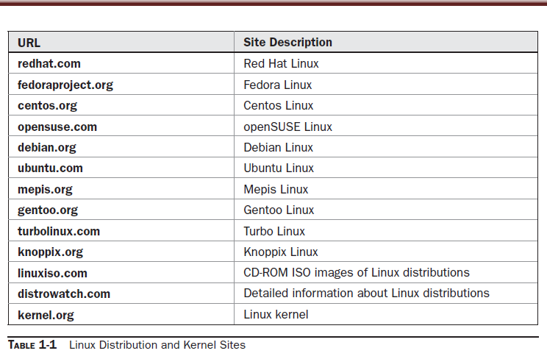

**3.2** **ComponentsofLinuxSystem**

Linux Operating System has primarily three components

* **Kernel** − Kernel is the core part of Linux. It is responsiblefor all major activities of this operating system. It consists of various modules and it interacts directly with the underlying hardware. Kernel provides the required abstraction to hide low level hardware details to system or application programs.
* **System Library** − System libraries are special functions orprograms using which application programs or system utilities accesses Kernel's features. These libraries implement most of the functionalities of the operating system and do not requires kernel module's code access rights.
* **System Utility** − System Utility programs are responsible todo specialized, individual level tasks.

Page 3

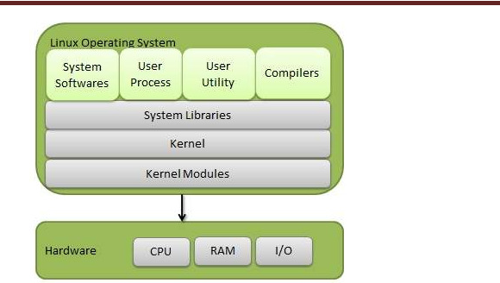

**KernelModevsUserMode**

Kernel component code executes in a special privileged mode called kernel mode with full access to all resources of the computer. This code represents a single process, executes in single address space and do not require any context switch and hence is very efficient and fast. Kernel runs each processes and provides system services to processes, provides protected access to hardware to processes.

Support code which is not required to run in kernel mode is in System Library. User programs and other system programs works in User Mode which has no access to system hardware and kernel code. User programs/ utilities use System libraries to access Kernel functions to get system's low level tasks.

**Basic Features**

Following are some of the important features of Linux Operating System.

* **Portable** − Portability means software can works on differenttypes of hardware in same way. Linux kernel and application programs support their installation on any kind of hardware platform.

Page 4

MKICS,BHARUCH UNIT-3 INTRODUCTION OF LINUX

* **Open Source** − Linux source code is freely available and it iscommunity based development project. Multiple teams work in collaboration to enhance the capability of Linux operating system and it is continuously evolving.
* **Multi-User** − Linux is a multiuser system means multipleusers can access system resources like memory/ ram/ application programs at same time.
* **Multiprogramming** − Linux is a multiprogramming systemmeans multiple applications can run at same time.
* **Hierarchical File System** − Linux provides a standard filestructure in which system files/ user files are arranged.
* **Shell** − Linux provides a special interpreter program which canbe used to execute commands of the operating system. It can be used to do various types of operations, call application programs. etc.
* **Security** − Linux provides user security using authenticationfeatures like password protection/ controlled access to specific files/ encryption of data.

**3.3** **Comparison of Windows and Linux.**

|  |  |
| --- | --- |
| **Windows** | **Linux** |
| Windows uses different data | Unix/Linux uses a tree like a |
| drives like C: D: E to stored files | hierarchical file system. |
| and folders. |  |
| NT needs 12 MB RAM | Linux needs 2MB RAM |
| NT needs 70 MB at least. | Linux needs at least 15 MB disk |
|  | space |
| Windows has different drives | There are no drives in Linux |
| like C: D: E |  |
| There are 4 types of user | There are 3 types of user |
| account types 1) Administrator, | account types 1) Regular, 2) |
| 2) Standard, 3) Child, 4) Guest | Root and 3) Service Account |
| Administrator user has all | Root user is the super user and |

|  |  |  |
| --- | --- | --- |
| administrative privileges of | has all administrative |  |
| computers. | privileges. |  |
| In Windows, you cannot have 2 | Linux file naming convention is |  |
| files with the same name in the | case sensitive. Thus, sample |  |
| same folder | and SAMPLE are 2 different |  |
|  | files in Linux/Unix operating |  |
|  | system. |  |
| In windows, My Documents is | For every user /home/username |  |
| default home directory. | directory is created which is |  |
|  | called his home directory. |  |
| Window is not command line | Linux is command line |  |
| interface | interface. |  |
| **No access** | **Full access** |  |
| This is not possible with | Linux belongs to the GNU |  |
| windows as | Public License ensures that |  |
|  | users can access (and alter) the |  |
|  | code to the very kernel that |  |
|  | serves as the foundation of the |  |
|  | Linux operating system. |  |
| **Licensing restriction** | **Licensing freedom** |  |
| You are bound to the number of | you can download a single copy |  |
| licenses you purchase, so if you | of a Linux distribution (or |  |
| purchase 10 licenses, you can | application) and install it on as |  |
| legally install that operating | many machines |  |
|  |  |
| system (or application) on only |  |  |
| 10 machines. |  |  |
|  |  |  |

Page 6